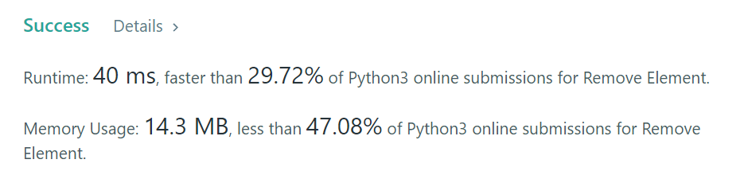

class Solution:

def removeElement(self, nums: List[int], val: int) -> int:

x = 0

for i in range(len(nums)):

if(nums[i]!=val):

nums[x] = nums[i]

x+=1

return(x)

others:

class Solution:

def removeElement(self, nums: List[int], val: int) -> int:

n = 0

while(n<len(nums)):

if nums[n] == val:

del nums[n]

continue

else:

n += 1

return n